Collagen Proteins:
Naturally Clean Additives for Cleaning Detergents
Surface Protection and Environmental Friendliness

Sioux City, IA – USA: GELITA will unveil its novel cleaning additive during the 2019 Cleaning Products US Conference at the event’s Supplier Innovation Forum (Wednesday, October 2, 2019 in Bethesda, MD). Here, Eric Yezdimer, PhD – Research & Business Development Manager at GELITA USA – will share the promising study results of NOVOTEC® CB800 in commercial and household glass, bath and kitchen cleaners.

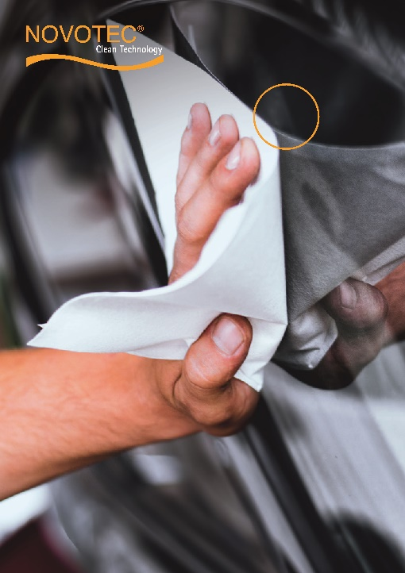
Proteins are a key performance factor in complex biological systems such as the human body, where they lubricate joints, stabilize bones and protect skin. GELITA – the maker of NOVOTEC® - has transferred this protein know-how to add value to diverse industrial applications.

NOVOTEC® CB800 consists of natural, polyfunctional protein molecules and adheres to surfaces such as steel, glass and aluminum. There, these molecules form protective layers of hydrated protein chains that facilitate the removal of dirt by increasing the water attraction on the surface. Conventional cleaning agents use silicates to protect surfaces or rely on water-repellent substances to prevent renewed soiling. Both produce residues that hamper the removal of water-insoluble dirt. By contrast, the protein layers of NOVOTEC® CB800 attract water. Dirt floats on the protective layer and is simply washed away when contacting water. New dirt fails to penetrate to the surface and can instead easily be wiped from the protective protein layer.

NOVOTEC® CB800 is made of natural collagen and, as an additive in cleaning solutions, enables impressive cleaning results at mild pH without aggressive chemicals, while improving the skin- and environmental-friendliness of cleaning agents.

Of note, NOVOTEC® CB800 was awarded the highest distinction of the gold award at the German Design Council’s German Innovation Award ceremony in June of 2018, where the jury was particularly impressed with how the revolutionary surface protecting product offers a highly effective and environmentally friendly solution for industrial cleaning.
https://www.gelita.com/en/products/gelatine/novotec-cb800

About GELITA:
As market leader, GELITA produces collagen proteins worldwide in 21 plants. These include particular gelatines for the production of technical applications, foodstuffs and pharmaceutical products as well as collagen peptides for the formulation of products to support musculoskeletal health. The group is headquartered in Eberbach, Germany. In 2018, GELITA employed about 2,550 people and achieved a turnover of approximately 696 million euros.
#
Lara Niemann | Marketing Director
GELITA | 2445 Port Neal Industrial Road, Sergeant Bluff, IA 51054
P: 712 943 1692 | M: 712 212 3968
E: lara.niemann@gelita.com | Visit us at: www.gelita.com

