Get in The Game with GELITA® Collagen Peptides and Gelatine
SupplySide West Booth: #4549 / GELITA Café: #5291

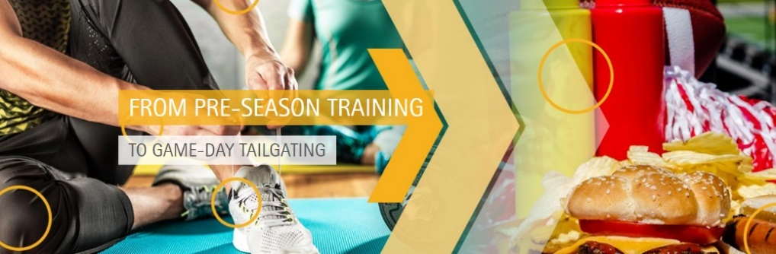
GELITA returns as the Official Collagen Protein Sponsor of SupplySide West (SSW). From pre-season training to game-day tailgating, collagen peptide supplementation is the ticket to hitting peak performance. Collagen peptides help build stamina, strength, and muscle mass while supporting the body’s tendons and ligaments for improved athletic agility. GELITA’s winning team of gelatines for soft-capsule, hard-capsule or gummy delivery systems is also sure to score big. https://www.gelita.com/en/ssw-2019

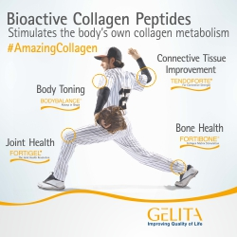
Pre-Season Training to Game Day Tailgating
Collagen, a major component of the human body, is a primary structural protein of connective tissues and supports musculoskeletal function and performance. With so much attention on the Sports Nutrition arena, GELITA’s roster of Bioactive Collagen Peptides® is sure to be SSW’s Most Valuable Player.

GELITA will serve up in-depth information on specific collagen peptides that support the body’s functions – both on and off the field. Register, via the SSW registration portal, for GELITA‘s Lunch Brief session (Friday, October 18: noon-1pm) for coaching on how these specific collagen peptides boost protein formulations targeted to support physical performance.

TENDOFORTE® has a pronounced stimulatory impact on the biosynthesis of extracellular matrix molecules in ligaments and tendons. BODYBALANCE® has been shown to decrease fat mass, increase lean body mass and provide more strength when consumed in combination with resistance exercise. FORTIGEL® supports joint health by increasing cartilage tissue metabolism.

Aside from sports nutrition, skin health is important on game day. VERISOL® collagen peptides are specially optimized to support firmer and smoother skin with fewer wrinkles. The posstive effect of VERISOL also shows in an improved skin surface structure, helping fight cellulite and a faster nail growth with reportedly less nail chipping. And, if you prefer to tailgate with a companion, PETAGILE® collagen peptides contribute to the maintenance of your pet’s joint health, supporting mobility for your most trusted friends.
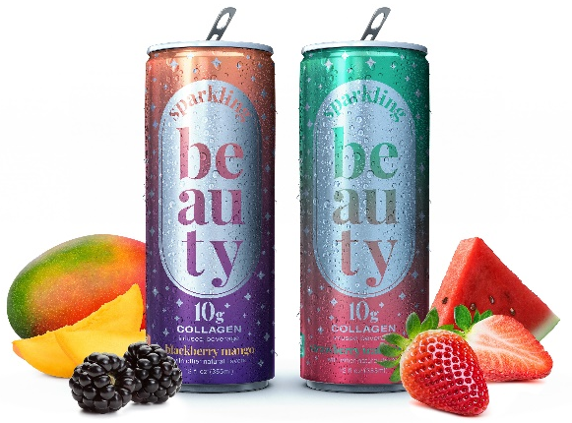
Tailgate at the GELITA Café with New Sparkling Beauty™
Sample GELITA’s roster of Bioactive Collagen Peptides® at the GELITA Café in festive tailgating foods and sporty beverages. Among other game-day favorites, GELITA will feature Sparkling Beauty™ (www.mysparklingbeauty.com), a one-of-a-kind, refreshing, patented, carbonated collagen beverage infused with VERISOL® for skin, hair and nail support - to look your best on game day, or any day. Experience the ease of including Bioactive Collagen Peptides® into an everyday training or beauty regimen.

Gelatine Delivery Systems: High Scoring with Consumers
As a winning component of the most popular delivery systems, GELITA offers high-performance and customizable gelatines for capsules and gummies. The latest addition to the team is GELITA® EC, the first and only patented gelatine product for true enteric performance. In the gummy game, GELITA offers solutions and technical know-how for both starchless and starch-based molding.

Get in the game with GELITA to look, feel and perform your best.
We’ll see you at the finish line!

#
About GELITA
www.GELITA.com

GELITA is the leading company for manufacturing and marketing collagen proteins. Coordinated from the headquarters in Eberbach, Germany, GELITA provides customers around the world with products of the highest standard, comprehensive technical expertise and sophisticated solutions. More than 20 sites and a global expert network ensure that state-of-the-art know-how is always available for customers. More than 135 years of experience in the field of collagen proteins are the basis of GELITA’s performance. A strong requirement for innovation is the driving force of the family-owned company that is always looking for new solutions for food, pharmaceutical, health & nutrition as well as for technical applications.

Within the range of collagen proteins, GELITA supplies collagen peptides with proven body-stimulating capabilities, tailor-made gelatines and non- or partly- water soluble collagens. This holistic range of products in combination with its vast experience in developing solutions for different applications makes GELITA the first choice for its customers. In today’s landscape of highest consumer demands, manufacturers of food products rely on natural, healthy, non-allergenic ingredients for their developments. Collagen proteins from GELITA are the perfect match for this as they fulfill these requirements and are foodstuffs in their own right (e.g. no E-number). They also possess a set of unique technical and physiological properties.

Besides the traditional use of collagen proteins as natural stabilizers and emulsifiers for countless products, they enable manufacturers to provide their products with other properties which are becoming more and more important. GELITA has intensified its research in developing solutions for physical mobility, weight management and beauty from within.

To Schedule Interviews: GELITA Contact:
Amy Maggio, ANM Marketing & Communications Lara Niemann, GELITA Global Marketing
312.617.6248 / amy.maggio@anmhealthcare.com 712.212.3928 / lara.niemann@gelita.com

