GELITA #AMAZINGCOLLAGEN AND #AMAZINGGELATINE AT IFT 2019

IFT 2019, Booth #2009: GELITA features Collagen Proteins – Collagen Peptides and Gelatine – with unique properties to enhance and optimize the quality of the most diverse beverage, food and pharmaceutical products – and, more!

Sioux City, IA, July 2019 – GELITA will return to the IFT Food Expo in New Orleans to showcase the amazing properties of collagen peptides and gelatine for the beverage, food and health & nutrition industries. GELITA’s pure protein and clean-label ingredients are perfectly suited to meet today’s consumer demands.

Visit GELITA’s booth for unique samples including GELITA® Gelatine “cocktail gummies” – these non-alcoholic gummies – in six fun flavors, will thrill your taste buds! Speaking of which – gummies with active ingredients are on trend! And, GELITA’s SMART TECHNOLOGY provides additional value for collagen peptides. Here, GELITA will be offering attendees samples of their Beauty Gummies – made with GELITA® Gelatine and VERISOL® Bioactive Collagen Peptides®. Finally, attendees will have the opportunity to sample a luscious dark chocolate coated raspberry yogurt protein nugget – offering the best of both worlds – protein and VERISOL® Bioactive Collagen Peptides®. Stop by GELITA’s Booth #2009 to explore the multiple functional and physiological advantages of collagen proteins by engaging with GELITA’s experts.

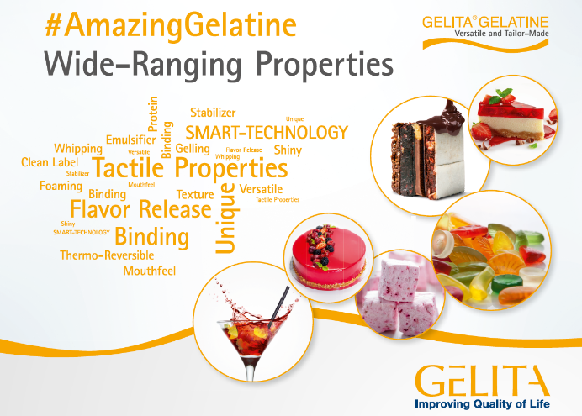
#AMAZINGGELATINE
Gelatine, a natural and pure protein extracted from collagen, is a dry white powder full of potential. This hydrocolloid swells rapidly in water, dissolves to a viscous solution when heated, then forms a gel when cooled – showcasing gelatine’s many excellent functional properties – as a binding, gelling and whipping agent; emulsifier and stabilizer; and, perfect film and foam former. It creates perfect textures, provides one-of-a-kind mouthfeel and enhances flavor release! These properties, which cannot be mimicked – as well as its irreplaceable thermo-reversible gelling behavior – make gelatine ideal in beloved confectionery, like gummies. And, GELITA® Gelatine is free from carbohydrates, cholesterol, fat, preservatives and purine. This, along with the functional versatility of gelatine and its nutritional value – make GELITA® Gelatine a must-have ingredient for modern beverages and foods.

#AMAZINGCOLLAGEN
Collagen Protein is the Body’s Protein - comprising about 30% of our total body protein – it is a vital component of our whole body – and, one of the most relevant and versatile ingredients in modern health & nutrition markets. Largely known for benefits to the human body, collagen is commonly associated with nutritional supplements. But, collagen peptides also lend themselves beautifully and easily to countless beverage and food applications. This is exciting because of the advances in collagen peptides research as it relates to the body’s collagen metabolism and human physiology. Recent scientific evidence confirms that the highest efficacy can be achieved when collagen is ingested orally. So, protein supplementation with collagen protein – generally in the form of collagen peptides – helps us stay strong, mobile, flexible and beautiful – for longer. However, collagen supplementation should not be considered a one size fits all solution. Research shows that GELITA Bioactive Collagen Peptides® are optimized to maximize the stimulatory effects on specific cells in the body...and, the level of stimulation is different for varying collagen peptide compositions. GELITA offers a diverse and versatile portfolio of Bioactive Collagen Peptides® to support bone, joint, muscle, skin and even ligaments and tendons health – making collagen-fortified beverages and foods the perfect vehicles for delivering natural health benefits for diverse groups of consumers.

To learn more about GELITA’s #AmazingCollagen and #AmazingGelatine – stop by Booth #2009 at IFT19. Visit with one of our experts to explore the diverse and versatile world of GELITA’s Collagen Peptides and Gelatine – and, how through innovation – we are finding new uses and producing new products to improve the quality of life…in all spheres of life.

About GELITA
GELITA is the leading company for manufacturing and marketing collagen proteins. Coordinated from the headquarters in Eberbach, Germany, GELITA provides customers around the world with products of the highest standard, comprehensive technical expertise and sophisticated solutions. More than 20 sites and a global expert network ensure that state-of-the-art know-how is always available for customers. Nearly 150 years of experience in the field of collagen proteins are the basis of GELITA’s performance. A strong requirement for innovation is the driving force of the family-owned company that is always looking for new solutions for food, pharmaceutical, health & nutrition as well as for technical applications.

Within the range of collagen proteins, GELITA supplies collagen peptides with proven body-stimulating capabilities, tailor-made gelatines and non- or partly- water soluble collagens. This holistic range of products in combination with its vast experience in developing solutions for different applications makes GELITA the first choice for its customers. In today’s landscape of highest consumer demands, manufacturers of food products have to rely on natural, healthy, non-allergenic ingredients for their developments. Collagen proteins from GELITA are the perfect match for this as they fulfill all of these requirements, a particular plus being the fact that they are foodstuffs in their own right (e.g. no E-number). They also possess a set of unique technical and physiological properties.

Besides the traditional use of collagen proteins as natural stabilizers and emulsifiers for countless products, they enable manufacturers to provide their products with other properties which are becoming more and more important. GELITA has intensified its research in developing solutions for physical mobility, weight management and beauty from within.

https://www.gelita.com/en/ift-2019

Media Contact:
Amy Maggio
ANM Marketing and Communications
P/R & Communications for GELITA
Phone: 312-617-6248 (mobile)
Email: amy.maggio@anmhealthcare.com

Company Contact:
Heather Arment
Marketing Coordinator – North America
GELITA USA
Phone: 712-943-1690 (office)
Email: heather.arment@gelita.com

