GELITA at Natural Products Expo West 2019
A Pioneer in Collagen Proteins: GELITA to Feature Collagen Protein Solutions for Sports Nutrition and Controlled Capsule Fill Release

GELITA will return to Natural Products Expo West to exhibit and showcase its latest collagen innovations and scientific findings for the nutritional supplement industry.

With much attention on the Sports Nutrition arena, GELITA’s roster of Bioactive Collagen Peptides® will be the stars of the show. TENDOFORTE® - GELITA’s latest collagen peptide brand – offers specific and optimized collagen peptides proven to strengthen tendons and ligaments. With its unique mode of action, this clean label ingredient is especially suitable for the booming sports nutrition market.

Finally, manufacturers of soft gelatine capsules will be able to see first-hand the complete spectrum of capsule fill release profiles – including the latest addition to GELITA’s delivery system portfolio: GELITA® EC for enteric gelatine capsule performance.

Collagen Ingredients Supported by Science
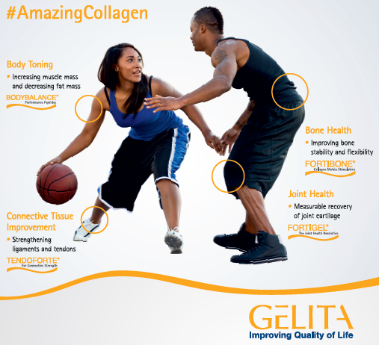
At its booth, GELITA will offer visitors to Natural Products Expo West in-depth information on specific collagen peptides that support the musculoskeletal system.
For example, TENDOFORTE® has a pronounced stimulatory impact on the biosynthesis of extracellular matrix molecules in ligaments and tendons. This makes it highly suitable for sports nutrition products targeted toward protecting soft tissues in both amateur and professional athletes.

As it makes up 95 percent of organic bone matrix, collagen is also essential for strong and stable bones. Now, a new study has investigated the long-term effects of specific collagen peptide supplementation on bone health. Experts will be available at the GELITA booth to talk visitors through the promising results, which confirm a pronounced increase in bone mineral density after FORTIBONE® supplementation.

GELITA experts will also be available for in-depth discussions on BODYBALANCE®, for body toning and increased muscle strength; FORTIGEL®, for supporting joint health and mobility; and, VERISOL®, for improved skin elasticity, wrinkle reduction, and even cellulite reduction as well as improved nail growth. And, GELITA’s Collagen Peptides are highly versatile – they can enhance and optimize the most diverse applications – from liquids to solids!

Gelatine Ingredients for Delivery Systems
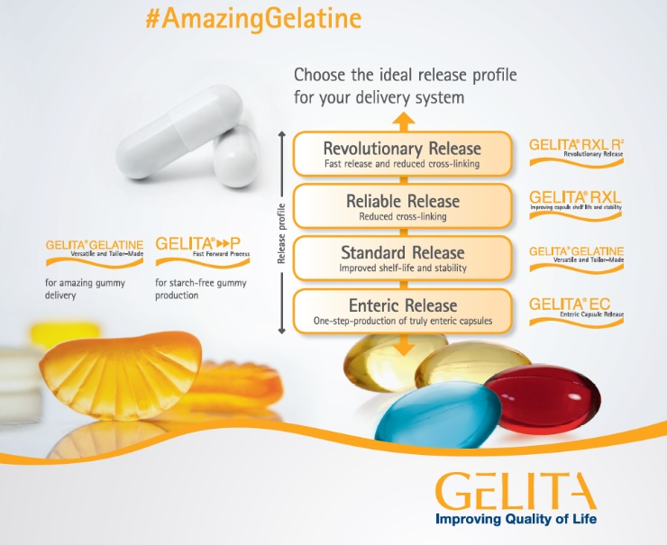
Soft gelatine capsules are a preferred delivery method for all kinds of nutrients and active ingredients. By adjusting the production process of soft capsule gelatine, GELITA can modify the specific effect, timing and duration of the fill release to tie in with consumer needs. The latest addition to its portfolio is GELITA® EC, the first and only gelatine product for true enteric performance.

GELITA® EC Gelatine product is just one product of a complete line-up for optimized gelatines for the world’s most popular delivery systems. GELITA has designed and developed a comprehensive portfolio of gelatines that provide excellent fill release performance for soft capsules, including GELITA® RXL for reduced cross-linking and improved shelf stablity; GELITA® RXL R² for faster release of the active fill and custom-designed standard gelatines for optimum peformance in hard- and soft-capsules and gummies.

Speaking of which, gummies with active ingredients are on trend. And, now, the global innovation leader in collagen proteins (collagen peptides and gelatine), GELITA has joined forces with Hänsel Processing GmbH and Winkler & Dünnebier Süβwarenmaschinen (WDS) to revolutionize gelatine gummy production – „Fast Forward Process“ technology – a startch-free production method that uses reusable silicone molds instead of traditional startch trays! To learn more about this innovative solution – be sure to stop by GELITA’s booth #3526 and visit with a GELITA expert!

About GELITA
GELITA is the leading company for manufacturing and marketing collagen proteins. Coordinated from the headquarters in Eberbach, Germany, GELITA provides customers around the world with products of the highest standard, comprehensive technical expertise and sophisticated solutions. More than 20 sites and a global expert network ensure that state-of-the-art know-how is always available for customers. Nearly 150 years of experience in the field of collagen proteins are the basis of GELITA’s performance. A strong requirement for innovation is the driving force of the family-owned company that is always looking for new solutions for food, pharmaceutical, health & nutrition as well as for technical applications.

Within the range of collagen proteins, GELITA supplies collagen peptides with proven body-stimulating capabilities, tailor-made gelatines and non- or partly- water soluble collagens. This holistic range of products in combination with its vast experience in developing solutions for different applications makes GELITA the first choice for its customers. In today’s landscape of highest consumer demands, manufacturers of food products have to rely on natural, healthy, non-allergenic ingredients for their developments. Collagen proteins from GELITA are the perfect match for this as they fulfill all of these requirements, a particular plus being the fact that they are foodstuffs in their own right (e.g. no E-number). They also possess a set of unique technical and physiological properties.

Besides the traditional use of collagen proteins as natural stabilizers and emulsifiers for countless products, they enable manufacturers to provide their products with other properties which are becoming more and more important. GELITA has intensified its research in developing solutions for physical mobility, weight management and beauty from within.

https://www.gelita.com/en/expo-west19

Media Contact:
Amy Maggio
ANM Marketing and Communications
P/R & Communications for GELITA
Phone: 312-617-6248 (mobile)
Email: amy.maggio@anmhealthcare.com

Company Contact:
Heather Arment
Marketing Coordinator – North America
GELITA USA
Phone: 712-943-1690 (office)
Email: heather.arment@gelita.com

