GELITA Symposium to explore food solutions off the beaten track
GELITA Food and Health & Nutritional Symposium to provide inspiration for better nutrition and health / Registration now open

GELITA, the world’s leading manufacturer of gelatine and collagen peptides, will host its bi-annual Food and Health & Nutrition Symposium in Heidelberg, Germany, from October 17-18 this year. The global industry meeting will uncover new perspectives, and provide insights into how to match product development to current as well as future consumer demands.
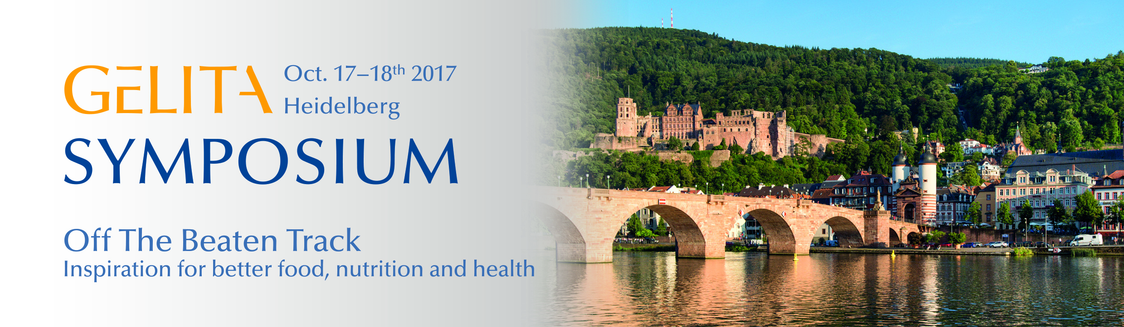
Following the theme “Off the beaten track – inspiration for better food, nutrition and health”, the symposium will allow participants to exchange ideas and experiences in a highly interactive environment. Top level lectures and discussions on diverse areas of expertise, such as molecular genetics of flavor perception, digitalization of food, collagen peptide research and interdisciplinary cooperation, will encourage attendees to evolve the industry’s thinking and explore new avenues. Beyond that, interactive hands-on sessions will provide ample opportunities for creative product design development.

Industry professionals from all over the world are encouraged to join this exceptional symposium, which runs for two half-days. The 300 Euro attendance fee covers hotel accommodation and catering, as well as a special evening event in the picturesque old town of Heidelberg.

For further information and to register, please visit www.gelita-symposium.com or email symposium@gelita.com

