**Press Release HNC 2017:** June 2017

**Solid Science for Smart Solutions**



**Shanghai, June 2017 – At this year’s HNC (Shanghai, June 20 – 22), the world’s leading manufacturer of collagen proteins, GELITA, will be showcasing the most up-to-date scientific evidence in collagen peptide research. With new high quality study results being available in the fields of mobility, body toning and beauty from within, GELITA strengthens its position as a preferred partner for the development of innovative supplements and functional food products with proven efficacy. At the show, the company will also present RXL R², a gelatine for soft capsules with revolutionary fast fill release performance.**

With their special nutritional and technological properties, [Bioactive Collagen Peptides®](https://www.gelita.com/en/products/collagen-peptides/bioactive-collagen-peptides) are enjoying increasing popularity in the food and dietary supplements market. At HNC, GELITA’s nutritional experts will inform visitors about several new scientific studies, for example with regards to mobility. New research on knee pain reduction in athletes and osteoporosis prevention in postmenopausal women has once again underlined the effectiveness of [FORTIGEL®](https://www.gelita.com/en/products/collagen-peptides/fortigel) and [FORTIBONE®](https://www.gelita.com/en/products/collagen-peptides/fortibone). By stimulating the body’s own cells to strengthen the structure of joints and bones, these specific collagen peptides operate from within and help people to stay active and mobile at every life stage.

Protein supplementation is of special interest for active men and women who work out in the gym. A recent study with GELITA’s [BODYBALANCE®](https://www.gelita.com/en/products/collagen-peptides/bodybalance)revealed a significant increase in fat-free body mass after resistance exercise and BODYBALANCE® supplementation compared to placebo. Furthermore, collagen peptide treatment led to significant fat mass reduction, whereas muscle strength and waist circumference improved after intake.

**Novel fields of application for VERISOL®**

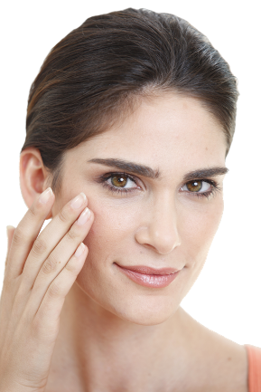

In recent years, a series of clinical studies have shown that supplementation with [VERISOL®](https://www.gelita.com/en/products/collagen-peptides/verisol) collagen peptides leads to long-term improvements in skin health. Now, the first ever clinical trial has investigated the efficacy of VERISOL® supplementation on nail growth and brittle nail syndrome. This study showed that supplementation led to clear improvements, and 8 out of 10 participants were satisfied with the performance of the treatment.

By influencing collagen metabolism directly from the inside, VERISOL® gives the skin its firm structure and is essential for skin elasticity and resistance. That it can also improve the wound healing process after surgery has now been shown in novel research. Patients treated with VERISOL® clearly showed better wound healing results than the placebo group.

**Taking fill release rates to a new level**

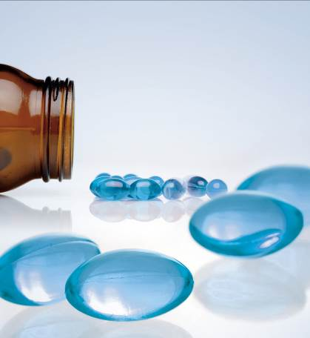

Besides collagen peptides, GELITA offers various grades of pharmaceutical gelatine. At HNC, the company’s Pharmaceutical Competence Team will present its latest development: GELITA® RXL R2, a product that takes the reduced cross-linking concept provided by [GELITA® RXL](https://www.gelita.com/en/products/gelatine/rxl) one step further and brings revolutionary release (R²) performance to the market (3 times faster fill release compared to standard gelatine). Trials clearly show that even under demanding storage conditions (6 months at 40C° and 75% r.h.), capsules with GELITA® RXL R2 offer an identical fill release profile to fresh capsules.

**Experts on stage**

GELITA’s leadership in the field of collagen proteins is reflected in two seminars provided at HNC, which will feature Bioactive Collagen Peptides® and Gelatine for gummy candies:

* Beyond beauty, what's hot in Bioactive Collagen Peptide science for clinical nutrition  
  Martin Walter, Product Manager, H&N  
  13:30-14:30, 20 June, meeting room E6-M35
* Gelatine production & properties and gummy candy process optimization  
  Eberhard Dick, Technical Product Manager, Food Research & Business Development  
  14:45-16:00, 20 June, meeting room E6-M35

GELITA is the leading company for manufacturing and marketing collagen proteins. Coordinated from the headquarters in Eberbach, Germany, GELITA provides customers around the world with products of the highest standard, comprehensive technical expertise and sophisticated solutions. More than 20 sites and a global expert network ensure that state-of-the-art know-how is always available for customers. More than 135 years of experience in the field of collagen proteins are the basis of GELITA’s performance. A strong requirement for innovation is the driving force of the family-owned company that is always looking for new solutions for food, pharmaceutical, health & nutrition as well as for technical applications.

Within the range of collagen proteins, GELITA supplies collagen peptides with proven body-stimulating capabilities, tailor-made gelatines and non- or partly- water soluble collagens. This holistic range of products in combination with its vast experience in developing solutions for different applications makes GELITA first choice for its customers. In today’s landscape of highest consumer demands, manufacturers of food products have to rely on natural, healthy, non-allergenic ingredients for their developments. Collagen proteins from GELITA are the perfect match for this as they fulfill all of these requirements, a particular plus being the fact that they are foodstuffs in their own right (e.g. no E-number). They also possess a set of unique technical and physiological properties.

Besides the traditional use of collagen proteins as natural stabilizers and emulsifiers for countless products, they enable manufacturers to provide their products with other properties which are becoming more and more important. GELITA has intensified its research in developing solutions for physical mobility, weight management and beauty from within.

**For further information please contact:**

|  |  |
| --- | --- |
| **Landy Ding**  Sales,Product & Marketing Manager Health & Nutrition China  Suite 1105, 11/F, Hongxiang building,  No.21 Huanghe Road, Huangpu District,  Shanghai 200003 P. R. China  phone: 021-5368 1250  [landy.ding@gelita.com](mailto:landy.ding@gelita.com) | **Oliver Wolf**  Head of B2B Marketing (global)  Global Marketing & Communication GELITA  Uferstraße 7  69412 Eberbach  **phone: +49 6271 84 2194**  [oliver.wolf@gelita.com](mailto:oliver.wolf@gelita.com) |

www.GELITA.com

**All press releases and pictures are available for download at** [**www.GELITA.com/press**](http://www.GELITA.com/press)